

**Product Dissection for Twitter**

### **Company Overview:**

Twitter was created in March 2006 by Jack Dorsey, Noah Glass, Biz Stone, and Evan Williams. It was launched in July of that year. Its former parent company, Twitter, Inc., was based in San Francisco, California and had more than 25 offices around the world. In October 2022, billionaire Elon Musk acquired Twitter for US$44 billion, gaining control of the platform and becoming CEO. Linda Yaccarino succeeded Musk as CEO on June 5, 2023, with Musk remaining as Chairman and CTO. In July 2023, Musk announced that Twitter will be rebranded to X and that the bird logo will be phased out. With a focus on storytelling, information sharing and user engagement, Twitter has attracted millions of users worldwide, making it one of the leading platforms in the social networking landscape.

### **Product Dissection and Real-World Problems Solved by Twitter:**

Twitter, a global social networking platform, has effectively addressed real-world challenges through its innovative product offerings. With a focus on sharing posts as tweets, Twitter empowers users to authentically share their experiences and pass down information on various occasions, bridging the gap between digital interactions and genuine connections. By allowing users to tweet, Twitter provides a solution to the need for meaningful expression and engagement for both the producer and consumer. This core feature solves the problem of connecting in an increasingly digital world, enabling users to form genuine relationships and engage in conversations that transcend geographical boundaries.

Twitter’s ingenious engagement features, such as likes, comments, and personalized content recommendations through the "Explore" feature as well as tweets from followed accounts on the user timeline, have revolutionized how users interact with content. By addressing the challenge of content overload, Twitter curates relevant content, helping users discover new accounts, posts, and trends tailored to their interests. Furthermore, Twitter hashtags have transformed content trends and made content discovery easier. This innovative approach effectively addresses the challenge of navigating through a sea of content to find relevant information, making it easier for users to connect with content aligned with their interests and engage in conversations that matter to them.

In conclusion, Twitter’s product design has successfully tackled real-world problems by creating a platform that nurtures creativity, fosters connections, and offers a space for self-expression. Through its diverse features, Twitter addresses the need for authentic engagement, content curation, and meaningful discovery, shaping the digital landscape and providing practical solutions to the evolving needs of its global user base.

### **Case Study: Real-World Problems and Twitter's Innovative Solutions**

Twitter, a leading social media platform, has not only revolutionized the way we share and consume content but has also addressed significant real-world challenges through its innovative features. By identifying user needs and leveraging technology, Twitter has positioned itself as a solution-driven platform that fosters connections, encourages self-expression, and enhances digital interactions.

#### **Problem 1: Disconnect in Digital Relationships and Authentic Information**

**Real-World Challenge:** As our lives become increasingly digital, the lack of genuine connections in online interactions has become a prevalent concern. Users often struggle to convey emotions and experiences effectively or consume information from authentic sources which causes the problem of misinformation among people on various accounts.

**Twitter’s Solution:**

Twitter recognized the need for authentic expression in digital interactions. By allowing users to share tweets in the form of texts, videos, photos etc. the platform creates a visually rich environment where users can share their lives more vividly. The power of authentic information bridges the gap between online interactions and real emotions, enabling users to maintain a right purview of things. Through this approach, Twitter effectively tackles the problem of disconnection and authenticity, nurturing and promoting genuine interactions.

#### **Problem 2: Information Overload**

**Real-World Challenge:** The vast amount of content available online can overwhelm users, making it challenging to discover relevant and engaging content aligned with their interests.

**Twitter’s Solution:**

Twitter addresses the issue of content overload through its innovative timeline feature. By leveraging advanced algorithms, the platform curates a personalized feed of tweets which are recommended to the users based on the accounts they follow and content they consume. This intelligent content recommendation system ensures that users encounter posts, accounts, and trends that match with their interests, mitigating the problem of information overload.

#### **Problem 3: Tackling the Influencer flood**

**Real-World Challenge**: In today’s digital world most other social media platforms are filled with different influencers and the products they promote. This makes browsing through the contents of those platforms somewhat irritating as there is no sense of genuineness and authenticity from the influencers or their contents.

**Twitter’s Solution**:

Twitter has addressed this issue by not giving any privileges to such influencers as other social platforms do and not pushing their content to the user's timeline. The users see what they like to see not limiting to people promoting brands.

#### **Problem 3: Inappropriate content**

**Real-World Challenge:** Today most of the platforms are used to post photos or videos where people post some contents that cannot be considered appropriate. All this is done so that the user could get more followers and get special privileges for the platform

**Twitter’s Solution:**

In today’s world where more than half the contents are shared just for the purpose of making money, twitter has limited its privileges to the people who have actual major achievements in life. This helps the consumer gain insight not limited to people dancing on camera. Twitter has also limited branding rules which makes it separated from other platforms and not let the influencer flood consume it.

**Conclusion:**

Twitter’s journey from to a global platform is a testament to its ability to identify real-world problems and provide innovative solutions. By fostering genuine connections, curating content, supporting creativity and authentic information. This case study showcases how Twitter's user-centric approach and continuous innovation have positioned it as a major platform in the social media domain, effectively shaping the way we engage and interact online.

### 

### 

### **Top Features of Twitter:**

1. **User Profiles:** Twitter allows users to create personal profiles, through features such as usernames, full names, bios, and profile pictures. This creates a personalized online presence that reflects each user's identity.
2. **Posts:** A core feature of Twitter is the ability to share posts popularly known as tweets. Users can add captions, tag locations, and other creative tools.
3. **Interactions**: Engagement lies at the heart of Twitter. Users can express appreciation by liking posts and sharing their thoughts through comments. It also provides the number of views per post. The "Share" feature allows users to share the content with others.
4. **Followers and Following:** The platform fosters connections through the "Follow" functionality. Users can follow other accounts to see their posts in their feed, creating a network of connections. Users can also view who is following them, enhancing transparency.
5. **Explore:** The "Explore" feature propels discovery by suggesting content based on user preferences and interactions. Users can explore posts, videos, and stories from accounts they don't follow, fostering a diverse online experience.
6. **Hashtags:** Twitter pioneered the use of hashtags, which categorize posts and enhance discoverability. Users can add relevant hashtags to their posts, making them accessible to a broader audience.

### **Schema Description:**

The schema for Twitter involves multiple entities that represent different aspects of the platform. These entities include Users, Posts, Comments, Likes, Followers, Hashtags, and more. Each entity has specific attributes that describe its properties and relationships with other entities.

**User Entity:**

Users are at the core of Twitter. The user entity contains information about each user:

* **UserID (Primary Key)**: A unique identifier for each user.
* **Username**: The chosen username for the user's account.
* **Email**: The user's email address for account-related communication.
* **Full_Name**: The user's full name as displayed on their profile.
* **Bio**: A brief description that users can use to express themselves.
* **Registration_Date**: The date when the user joined Twitter.

**Post Entity:**

Posts capture the visual content shared on the platform:

* **PostID (Primary Key):** A unique identifier for each post.
* **UserID (Foreign Key referencing User Entity**): The user who created the post.
* **Tweet**: Text accompanying the post.
* **Image_URL**: The URL of the image or video content if shared.
* **Location**: The tagged location associated with the post.
* **Post_Date**: The date when the post was created.

**Comment Entity:**

Comments enable users to engage in conversations around posts:

* **CommentID (Primary Key)**: A unique identifier for each comment.
* **PostID (Foreign Key referencing Post Entity):** The post being commented on.
* **UserID (Foreign Key referencing User Entity)**: The user who posted the comment.
* **Text**: The text of the comment.
* **Comment_Date**: The date when the comment was posted.

**Like Entity:**

Likes represent user appreciation for posts:

* **LikeID (Primary Key):** A unique identifier for each like.
* **PostID (Foreign Key referencing Post Entity):** The post being liked.
* **UserID (Foreign Key referencing User Entity):** The user who liked the post.
* **Like_Date:** The date when the like was registered.

**Follower Entity:**

Followers establish connections between users:

* **FollowerID (Primary Key)**: A unique identifier for each follower relationship.
* **FollowingUserID (Foreign Key referencing User Entity)**: The user who is being followed.
* **FollowerUserID (Foreign Key referencing User Entity)**: The user who is following.
* **Follow_Date**: The date when the following relationship was initiated.

**Hashtag Entity:**

Hashtags categorize and group content:

* **HashtagID (Primary Key):** A unique identifier for each hashtag.
* **Tag**: The actual text of the hashtag.

**PostHashtag Entity:**

Associates posts with hashtags:

* **PostHashtagID (Primary Key)**: A unique identifier for each association.
* **PostID (Foreign Key referencing Post Entity)**: The post associated with the hashtag.
* **HashtagID (Foreign Key referencing Hashtag Entity)**: The hashtag associated with the post.

**Relationships are:**

* **Users post Posts –** Each user can post multiple posts.
* **Users comment on Posts –** Users can comment on multiple posts, and each post can have multiple comments.
* **Users like Posts –** Users can like multiple posts, and each post can have multiple likes.
* **Users follow other Users –** Users can follow multiple users and be followed by multiple users.
* **Posts have Hashtags –** Posts can have multiple hashtags, and each hashtag can be associated with multiple posts.

**ER Diagram:**

Let's construct an ER diagram that vividly portrays the relationships and attributes of the entities within the Twitter schema. This ER diagram will serve as a visual representation, shedding light on the pivotal components of Twitter's data model. By employing this diagram, you'll gain a clearer grasp of the intricate interactions and connections that define the platform's dynamics.

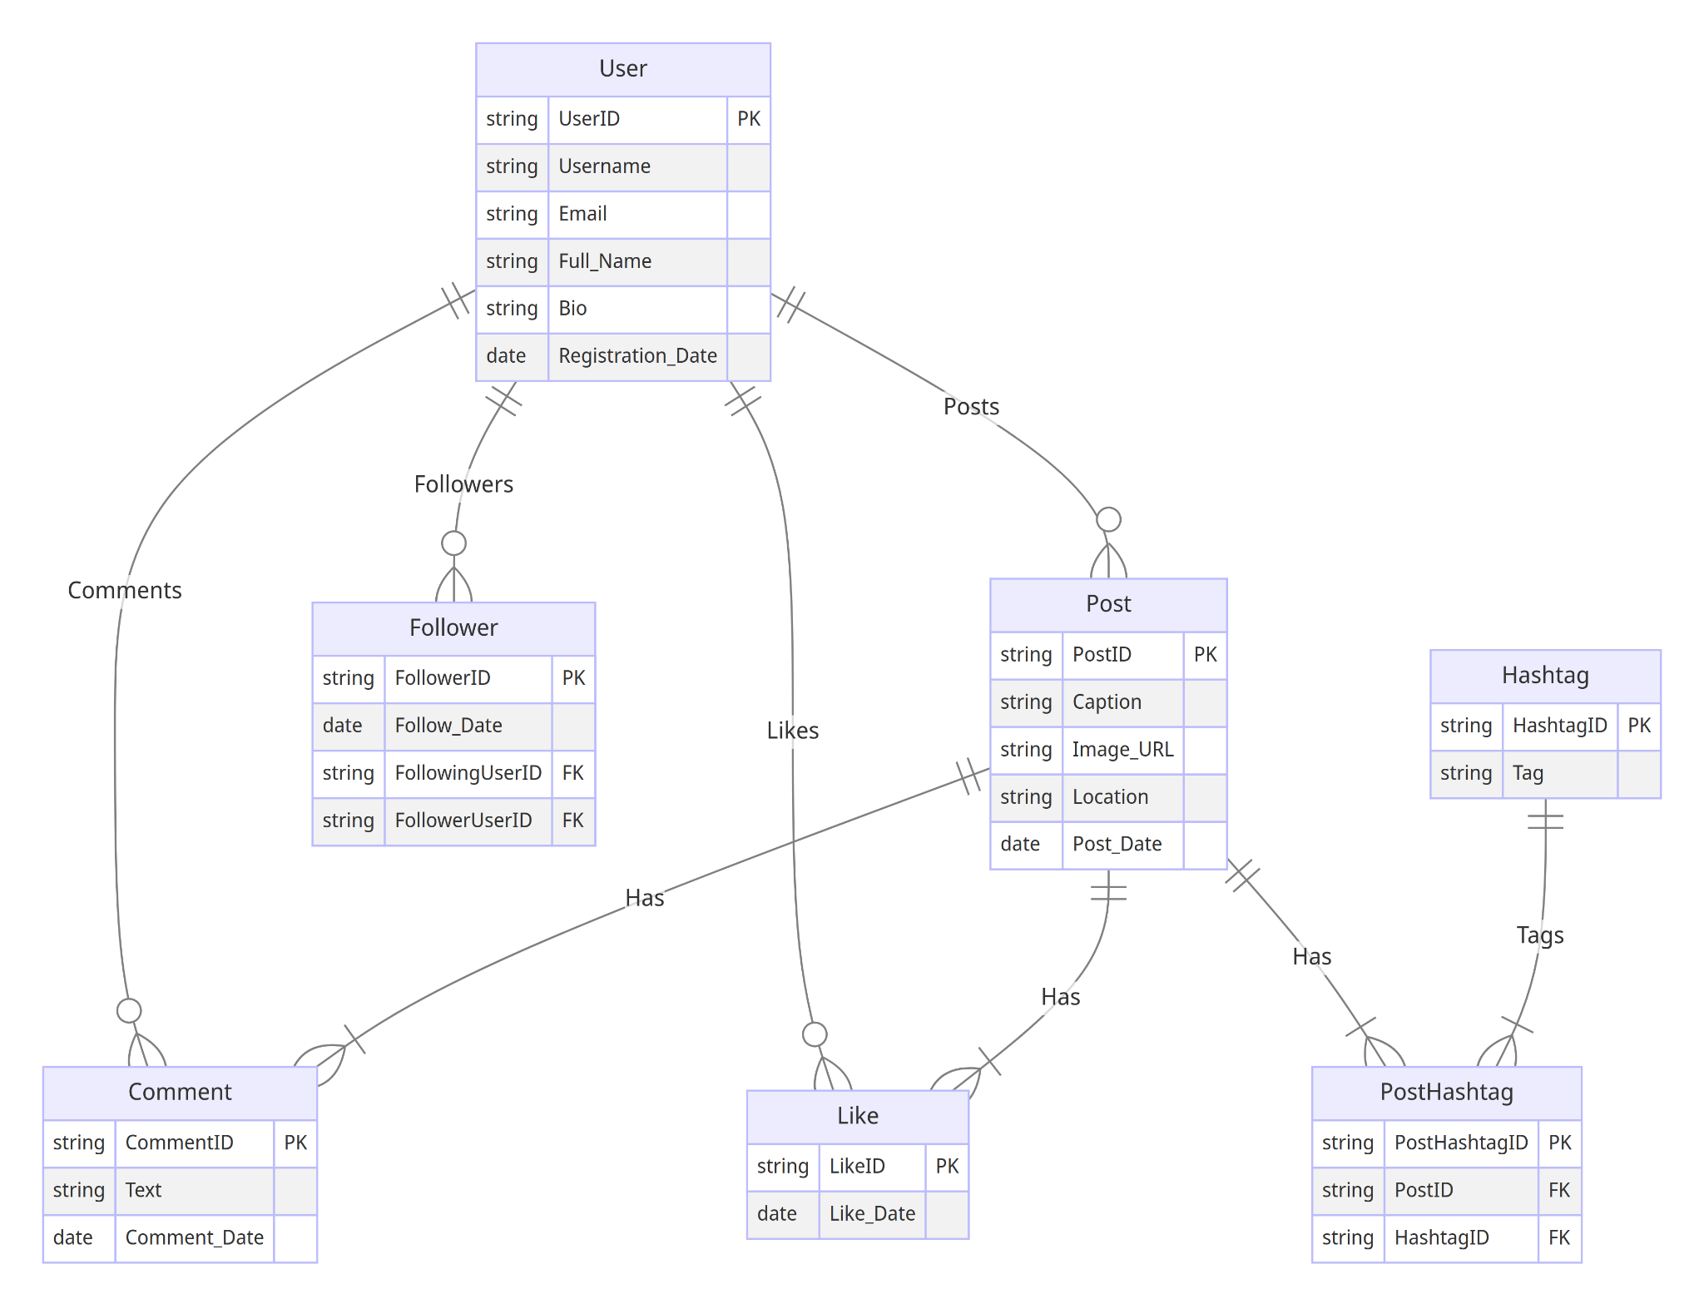

### **Conclusion**

In this case study, we delved into the design of Twitter's schema and Entity-Relationship diagram. Twitter has revolutionized the way people share and engage with visual content, fostering connections and creative expression. The platform's intricate data model, consisting of entities like users, posts, comments, likes, followers, hashtags, and associations, forms the foundation for its seamless functionality. By understanding this schema, we gain insight into how Twitter effectively manages the complexities of user interactions and content sharing, contributing to its widespread popularity and continued growth in the world of social media.